
Student Name: Darshinie Karani.V.M Reg. No :192520033 Course Code: CSA0504 Slot:C Course Name: Database Management Systems Course Faculty: Dr.R Kesavan
Project Title: Slot-Booking & Result-Processing Engine — Query Optimization & Transaction Management
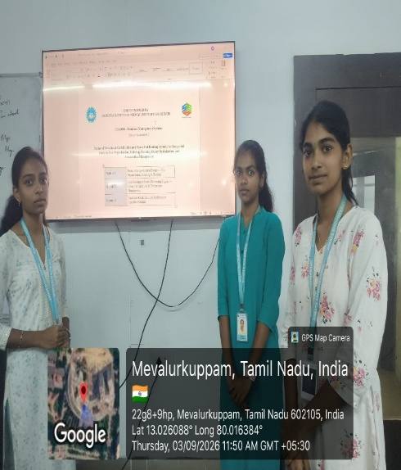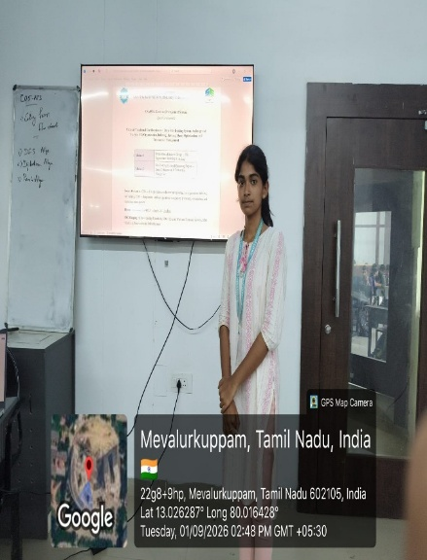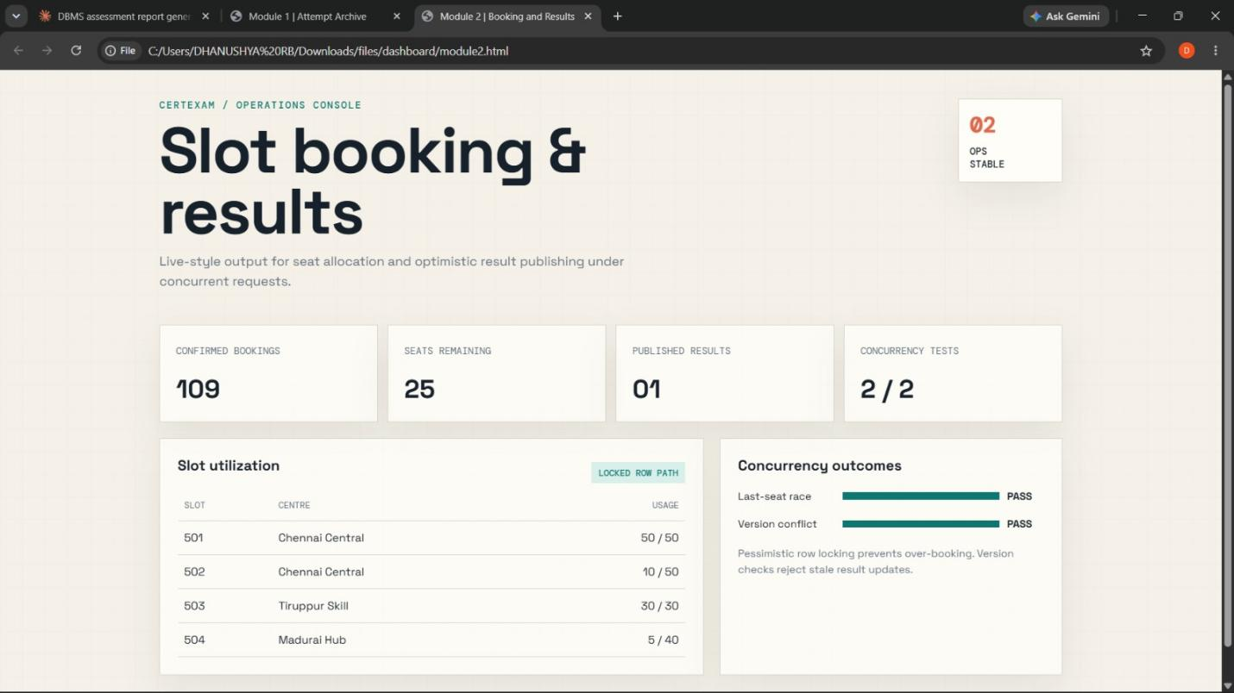
Project Description: (here you write what you did in this project (contribution) including Model Description
The slot-booking and result-processing system is designed to provide reliable database operations during concurrent access. A normalized 3NF relational schema is used to separate the centre, exam slot, booking, and result entities. This reduces data redundancy and prevents update anomalies while allowing the system to manage slot capacity efficiently. Query performance is improved by creating indexes on foreign keys and frequently used WHERE and JOIN columns. Complex queries are also optimized by rewriting correlated subqueries as JOIN or EXISTS operations and validating the improvements using EXPLAIN or EXPLAIN ANALYZE.
For concurrent slot booking, pessimistic concurrency control is implemented using SELECT ... FOR UPDATE within a transaction under REPEATABLE READ isolation. This locks the required slot while its capacity is checked and updated, preventing over-booking. Result publishing uses optimistic concurrency control with a version column. If another examiner modifies the same result before the update, the version mismatch detects the conflict and prevents a silent overwrite. Transactions use COMMIT, ROLLBACK, and SAVEPOINT to maintain data consistency and ensure that partial failures do not leave incorrect or incomplete records.

Student Signature Guide Signature

